**Course-End Project: Crime Analysis**

**1. Overall Crime Statistics Dashboard:**

[A]. For personnel and resource management, the department needs to understand the count and types of crimes reported across the city. Mark the locations on a geo-map highlighting the locations with recent criminal history.

Ans – Add the Crime data inside Microsoft excel then taken **cnt(sheet)** table in column and **primary type** in row. To get crime added **filter** as **top 10.**

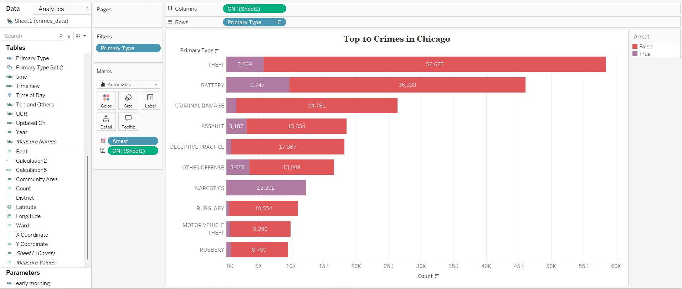

Marked the **location**

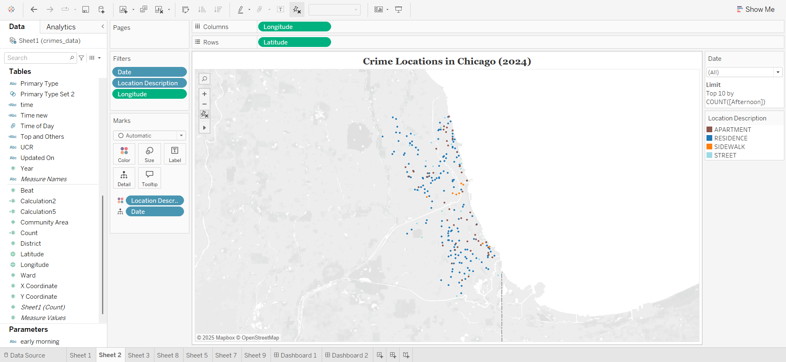

[B]. Identify the most common criminal incidents reported

[C]. In this introductory dashboard, include a live crime feed to exhibit the total number of crimes reported to date for the current year and the most recently reported crimes with their time and locations

Ans-

Added hour of Day as calculate field

**2. Time Period Analysis Dashboard:** Along with locations, the study of crime statistics across time statistics is also crucial for understanding the patterns and planning those preventive strategies.

[A]. Study distribution count of crime incidents across different time periods, such as day of the week or hour

[B]. Further, explore the percentage of incident reporting for several time blocks (morning, afternoon, evening, and night)

Ans of [a] and [b] – Added group and parameter as several time zone

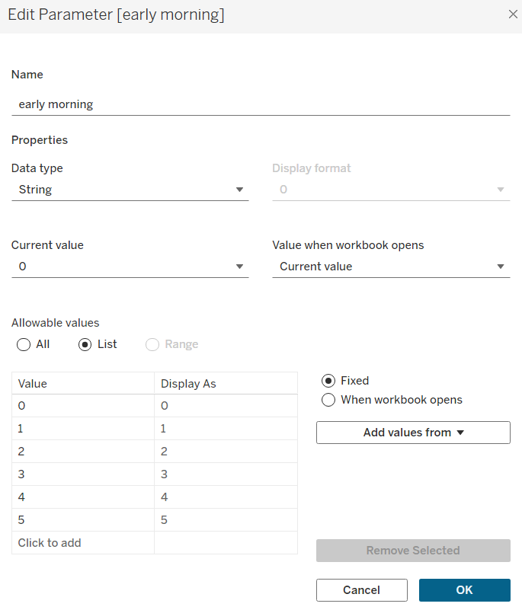

Added calculation field for several time blocks

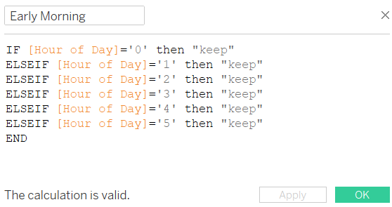

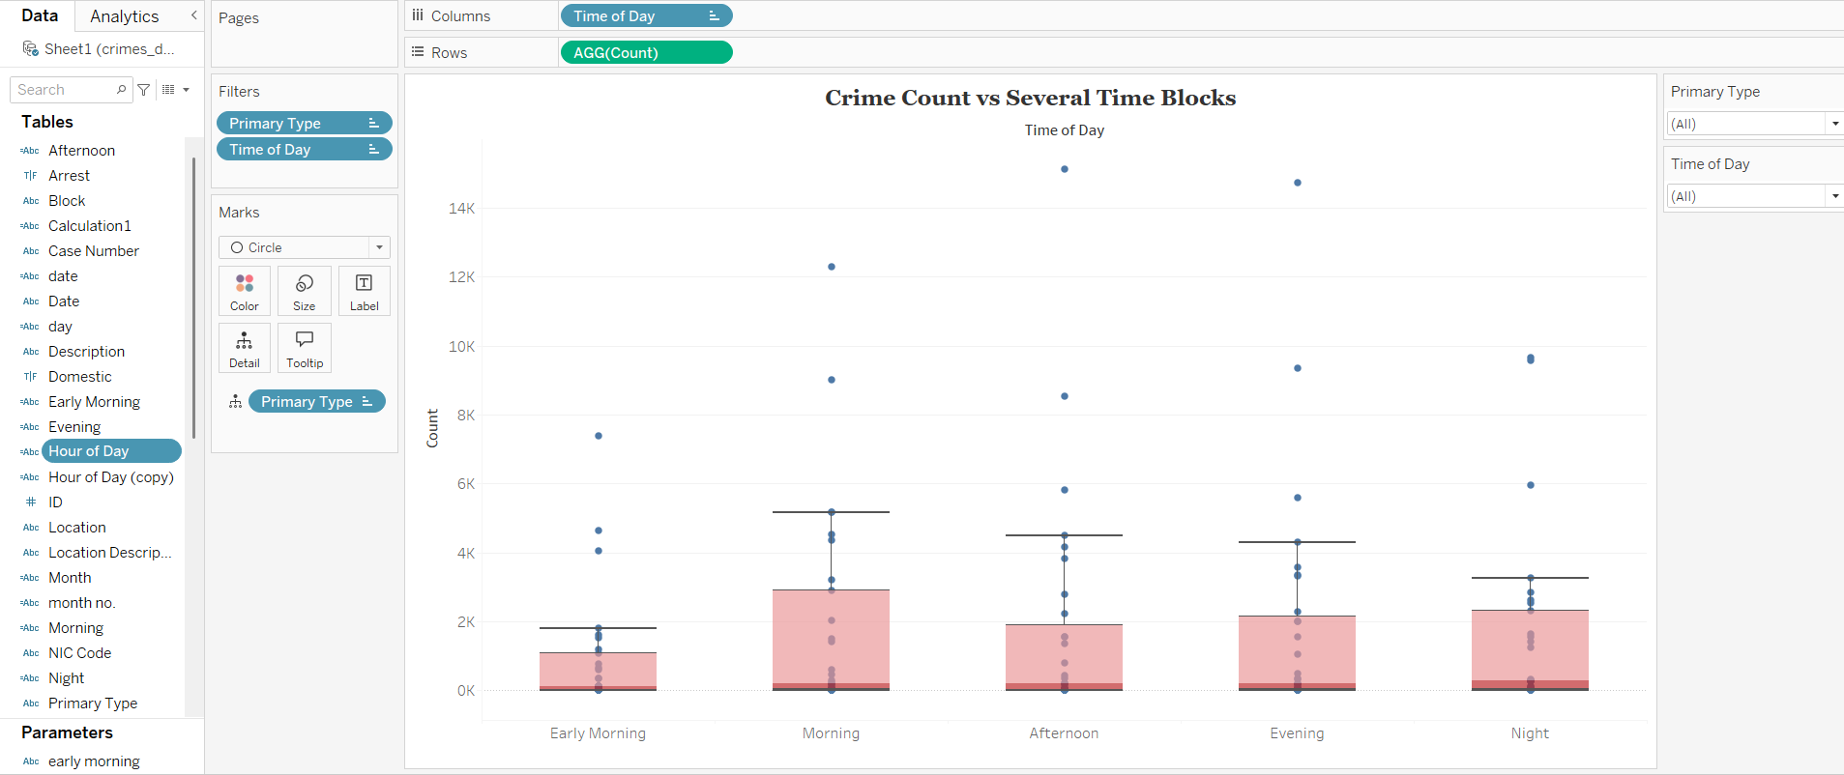

**3. Trend Analysis Dashboard:**

[A]. Create a dashboard to study the change in crime rate over different years

[B]. Compare the change in the incident reporting over the years for the same date and time

Ans of a and b

**4. Comparative Analysis:**

[A]. Study the distribution of incidents reported where an arrest was made vs. not

[B]. Identify what percentage of the reported incidents under each incident category are severe

[C]. To make the dashboard interactive, provide filters for incident type and location in these dashboards for a granular study

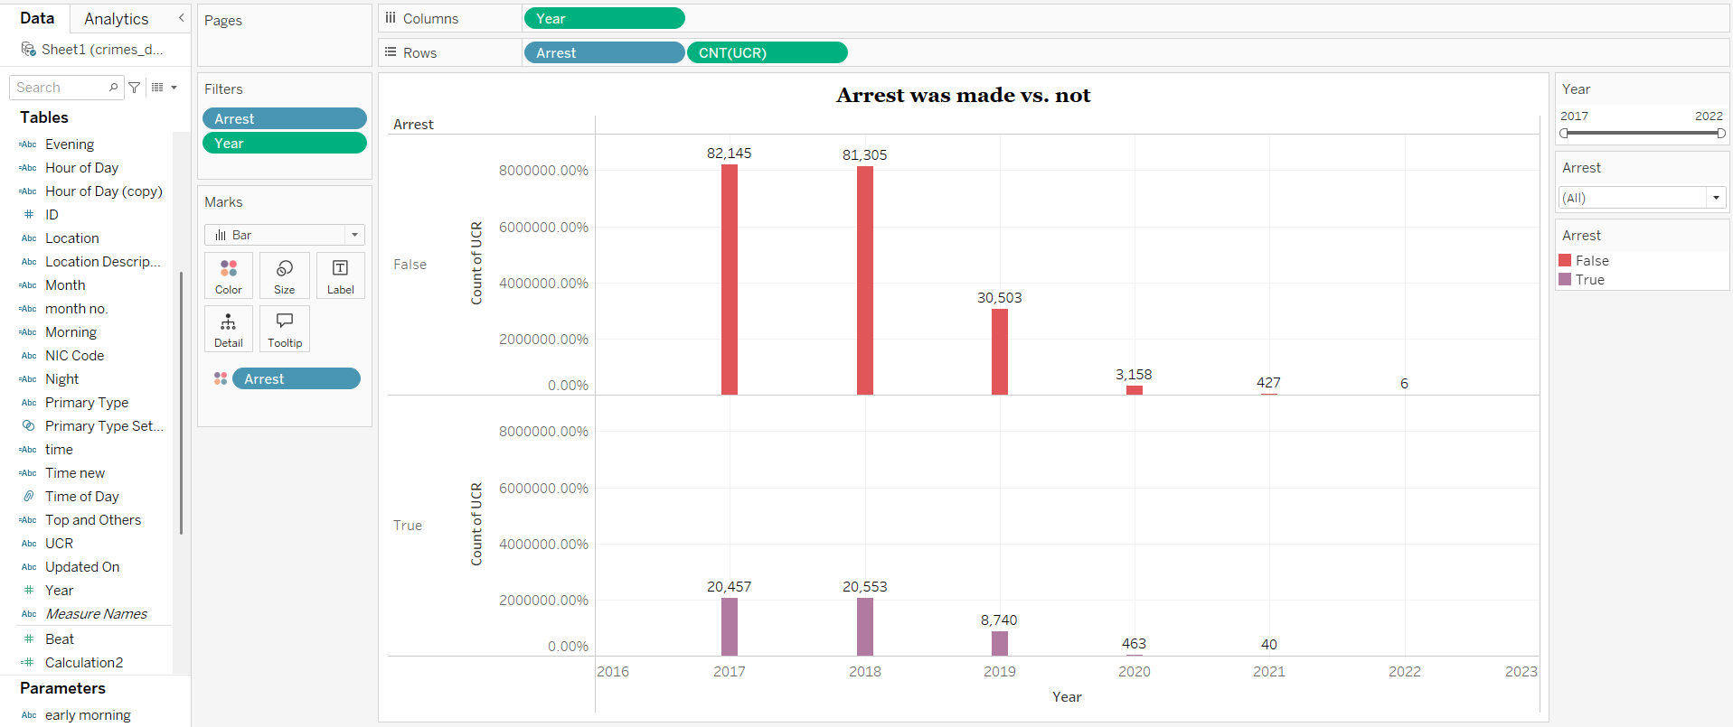

Final Crime Analysis Dashboard

